AUTOMATIC
ROBOTIC ARM.

ROBOTICS:

A mechanical device that sometimes resembles a human and is capable of performing a variety of often complex human tasks on command or by being programmed in advance is defined as a robot

A Robot never becomes fulfill until it can take decisions. We can’t go for computers for the computation & intelligence. But we can use single chip microcontrollers for controlling. This robot is not going to do any big tasks there will only be predefined tasks. The robot’s full control is embedded into one chip which is otherwise known as embedded systems designing.

To make a robot we must surely know to at least use a single microcontroller. So let us see about Embedded System thru 8051.

In this project we show that how we convert simple robotic arm into a fully automatic robotic arm.. After putting a automation logic it is very useful for industrial automation.
In this project we use many step to control automation system.

CONVEYER BELT SYSTEM.

INFRA RED SENSOR INTERRUPTION LOGIC.

AUTO GRIPPER SYSTEM

AUTO MOVE ROBOTIC ARM..

CONVEYER BELT SYSTEM.

In this project we use slow speed motor to tune the stepper motor. Here in this project we use slow speed dc gear motor to run the conveyer belt. Start signal is provided by the microcontroller circuit. In the main unit when the supply unit is on, then conveyer belt is not start automatically. Start switch of the conveyer belt is provided by the microcontroller.

First work of the microcontroller is to start the conveyer belt after pressing a switch and now monitor the infra red sensor for reflection.

After conveyer belt is start then our infra red sensor monitor the object which is object the high of regulator object. When conveyer belt is start then object is move on the belt. If the object is suitable for the machine then object move on the belt but if the object is above height then infra red sensor sense the signal with the help of reflection from the object. When infra red sensor reflect the rays then machine sense the signal through photodiode . Photodiode and infra red sensor connected in pair with the one certain height. When any object is passing in the front of the sensor then object reflect the signal and at this time machine sense the signal and conveyer belt is stop.

Now conveyer is stop automatically and gripper connected above the sensor is activate automatically and grip the object. For the gripper we use second dc gear motor. Control signal to grip the object is provided by the microcontroller itself.

After gripping the object third motor is start and move the robotic hand to other side , after some delay third motor is stop and now gripper is open itself and through the object in the basket. After throwing the object in the basket third motor is again start then move the robotic hand to reverse side with the same delay and star the conveyer belt automatically

MAIN part of this project is microcontroller that provide a signal to the robotic arm to start the conveyer belt then sense the reflection , if reflection is there then stop the conveyer belt, after stop the conveyer belt grip the gripper, move the robotic hand, and drop the object in basket and again move the conveyer belt. All this signal is provide by the microcontroller.
For this purpose we use ic 89s51 as a main microcontroller to control all this function.
89c51 microcontroller is a main ic of this project. To drive the motor’s . Here we use microcontroller for this purpose. We wrote a program for this ic. Program is to be written in the ASM codes and then this code is converted into hex code with the help of the assembler. In this project we use 8051 ide software to assemble the asm codes into hex code. Once the code is converted into hex code then we tranfer this code in the blank ic with the help of program kit connected with the computer. After transfer the hex code in the blank ic our ic is ready for the project .

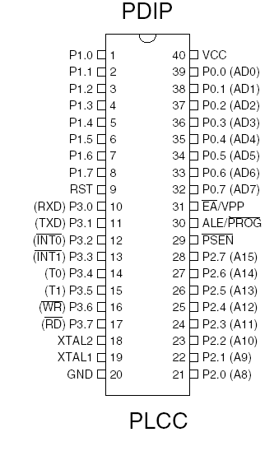

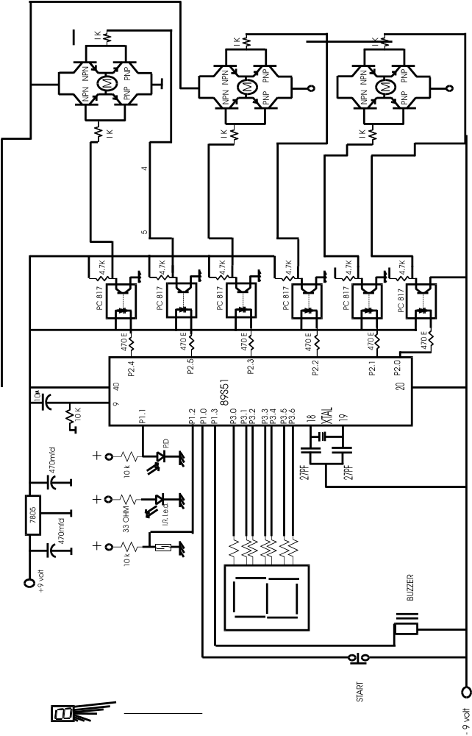

8051 micro controller

The 8051
The 8051 developed and launched in the early 80`s, is one of the most popular micro controller in use today. It has a reasonably large amount of built in ROM and RAM. In addition it has the ability to access external memory.
The generic term `8x51` is used to define the device. The value of x defining the kind of ROM, i.e. x=0, indicates none, x=3, indicates mask ROM, x=7, indicates EPROM and x=9 indicates EEPROM or Flash.
A note on ROM
The early 8051, namely the 8031 was designed without any ROM. This device could run only with external memory connected to it. Subsequent developments lead to the development of the PROM or the programmable ROM. This type had the disadvantage of being highly unreliable.
The next in line, was the EPROM or Erasable Programmable ROM. These devices used ultraviolet light erasable memory cells. Thus a program could be loaded, tested and erased using ultra violet rays. A new program could then be loaded again.
An improved EPROM was the EEPROM or the electrically erasable PROM. This does not require ultra violet rays, and memory can be cleared using circuits within the chip itself.
Finally there is the FLASH, which is an improvement over the EEPROM. While the terms EEPROM and flash are sometimes used interchangeably, the difference lies in the fact that flash erases the complete memory at one stroke, and not act on the individual cells. This results in reducing the time for erasure.

Different microcontrollers in market.

- PIC One of the famous microcontrollers used in the industries. It is based on RISC Architecture which makes the microcontroller process faster than other microcontroller.

- INTEL These are the first to manufacture microcontrollers. These are not as sophisticated other microcontrollers but still the easiest one to learn.

- Atmel Atmel’s AVR microcontrollers are one of the most powerful in the embedded industry. This is the only microcontroller having 1kb of ram even the entry stage. But it is unfortunate that in India we are unable to find this kind of microcontroller.

Intel 8051

Intel 8051 is CISC architecture which is easy to program in assembly language and also has a good support for High level languages.

The memory of the microcontroller can be extended up to 64k.

This microcontroller is one of the easiest microcontrollers to learn.

The 8051 microcontroller is in the field for more than 20 years. There are lots of books and study materials are readily available for 8051.

Derivatives

The best thing done by Intel is to give the designs of the 8051 microcontroller to everyone. So it is not the fact that Intel is the only manufacture for the 8051 there more than 20 manufactures, with each of minimum 20 models. Literally there are hundreds of models of 8051 microcontroller available in market to choose. Some of the major manufactures of 8051 are

- Atmel

- Philips

Philips
The Philips‘s 8051 derivatives has more number of features than in any microcontroller. The costs of the Philips microcontrollers are higher than the Atmel’s which makes us to choose Atmel more often than Philips

Dallas
Dallas has made many revolutions in the semiconductor market. Dallas’s 8051 derivative is the fastest one in the market. It works 3 times as fast as a 8051 can process. But we are unable to get more in India.

Atmel
These people were the one to master the flash devices. They are the cheapest microcontroller available in the market. Atmel’s even introduced a 20pin variant of 8051 named 2051. The Atmel’s 8051 derivatives can be got in India less than 70 rupees. There are lots of cheap programmers available in India for Atmel. So it is always good for students to stick with 8051 when you learn a new microcontroller.

Architecture

Architecture is must to learn because before learning new machine it is necessary to learn the capabilities of the machine. This is some thing like before learning about the car you cannot become a good driver. The architecture of the 8051 is given below.

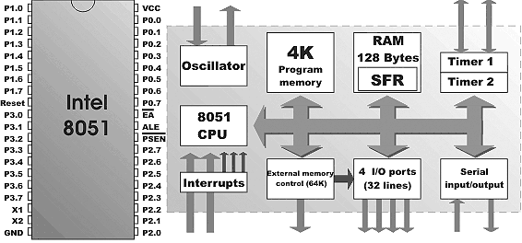

The 8051 doesn’t have any special feature than other microcontroller. The only feature is that it is easy to learn. Architecture makes us to know about the hardware features of the microcontroller. The features of the 8051 are

- 4K Bytes of Flash Memory
- 128 x 8-Bit Internal RAM
- Fully Static Operation: 1 MHz to 24 MHz
- 32 Programmable I/O Lines
- Two 16-Bit Timer/Counters
- Six Interrupt Sources (5 Vectored)
- Programmable Serial Channel
- Low Power Idle and Power Down Modes

Power supply:

8051 can handle power supply of 3.5 volts to 7 volts with no problem. Always use a Decoupling Capacitor between the Power supply and the Ground. Decoupling capacitors are used to avoid the spikes. Pin 40 is for VCC and Pin 20 is for Gnd.

Reset Circuitry:

As soon as you give the power supply the 8051 doesn’t start. You need to restart for the microcontroller to start. Restarting the microcontroller is nothing but giving a Logic 1 to the reset pin at least for the 2 clock pulses. So it is good to go for a small circuit which can provide the 2 clock pulses as soon as the microcontroller is powered.

This is not a big circuit we are just using a capacitor to charge the microcontroller and again discharging via resistor.

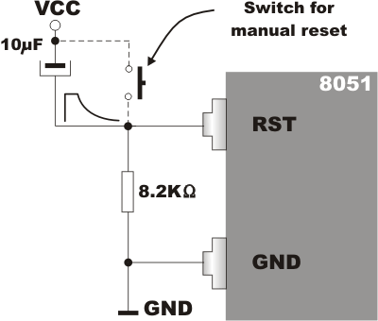

Crystals

Crystals provide the synchronization of the internal function and to the peripherals. Whenever ever we are using crystals we need to put the capacitor behind it to make it free from noises. It is good to go for a 33pf capacitor.
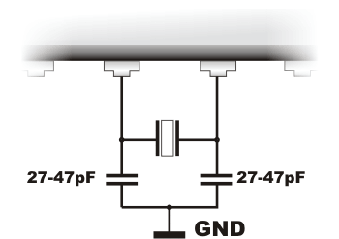
We can also resonators instead of costly crystal which are low cost and external capacitor can be avoided.

But the frequency of the resonators varies a lot. And it is strictly not advised when used for communications projects.

Using Keil C.

There is nothing much different from the Turbo C we used and Keil C we are going to use. The only difference is that we need to change the header file of the microcontroller we are going to use.

#include<AT89x51.h>

Here in the above code I was using At89c51 so I am including this file for compiling.

After including the file we must declare main function and start writing the code.

#include<AT89x51.h>
void main()
{
int i;
while(1){
for (i = 0;i< 9000;i++)
P1_1=0;
for (i = 0;i< 9000;i++)
P1_1=1;
}
}

These is the code for the blinking of the led.

SFR are the Special Functional Registers. These are used to control the peripherals in the microcontroller these are nothing but addresses in the ram.

Let us see the architecture in detail.

- Ports

- Timers

- Interrupts

Ports

Ports used to communicate with the outside world. It is same like our computer without ports our computer remains useless. If there are no ports in computer then we cant have any devices attached to the computer. Even we cant use Keyboard and monitors.

8051 is having 4 ports & each has 8 I/O Pins. Simplest I/O Port in all microcontroller.

Port0, Port2 can be used for the External addressing. If our code has exceeded the 4kb then we need to use extra rom & ram. For addressing the extra memory chips we need to loose our Port 0 & port 2.

Port3 is one of the important ports; this has the serial port, timers and interrupts pins.

Port 1 is free can be used only as Port!!

How to use a Port?

It is really easy to use the ports of 8051. When you say that you have connected an Led in Port1 pin1 and when you want to light the led just use the code
P1_1=1;

To check whether a switched pressed or not, you can use the normal if condition statement.

If (P1_1==1)
P1_2=1;
Else
P1_2=0;

Always sink an led rather lighting an led. In the above steps we were lighting the led but it is good to sink. Sinking is nothing instead of giving 5V we will provide the ground for the led.

Try to use negative active switches.

It is been always advised before using a port for input we need to high the port.

Atmel’s 2051 has a onboard voltage comparator in the port which is much useful for the light following kind of robots.

In this project we use three dc motor to run the conveyer belt and robotic arm. One motor to run the conveyer belt and second motor is for the gripper and third motor is for the hand movement,

Motors

To make the robots mobile we need to have motors and the control circuitry that could control the motors. There are different kinds of motors available for different application.

- DC motor
- Stepper motor
- Servo motor

DC motors
These are the motors that are commonly found in the toys and the tape recorders. These motors change the direction of rotation by changing the polarity. Most chips can't pass enough current or voltage to spin a motor. Also, motors tend to be electrically noisy (spikes) and can slam power back into the control lines when the motor direction or speed is changed.
Specialized circuits (motor drivers) have been developed to supply motors with power and to isolate the other ICs from electrical problems. These circuits can be designed such that they can be completely separate boards, reusable from project to project.
in this project we use dc gear motor with the micro controller with special interface circuit. In the interface circuit we use op to coupler circuit. . for controlling three motor we are using total six control. From the microcontroller we get a six output to control three motor’s. By using six control we control the direction of three motor . We use six optocoupler to interface the three motor’s here in this project. Output of the six optocoupler is connected to the three h bridge circuit. H bridge circuit not only take a power hold of this project but at the same time control the direction of the motor .
A very popular circuit for driving DC motors (ordinary or gearhead) is called an H-bridge. It's called that because it looks like the capital letter 'H' on classic schematics. The great ability of an H-bridge circuit is that the motor can be driven forward or backward at any speed, optionally using a completely independent power source.

The H-Bridge Circuit
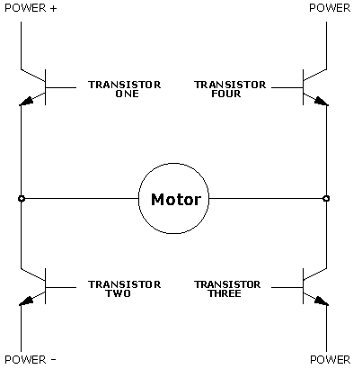

This circuit known as the H-bridge (named for its topological similarity to the letter "H") is commonly used to drive motors. In this circuit two of four transistors are selectively enabled to control current flow through a motor.
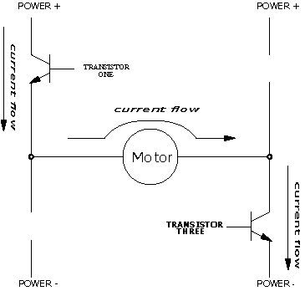

opposite pair of transistors (Transistor One and Transistor Three) is enabled, allowing current to flow through the motor. The other pair is disabled, and can be thought of as out of the circuit.
By determining which pair of transistors is enabled, current can be made to flow in either of the two directions through the motor. Because permanent-magnet motors reverse their direction of turn when the current flow is reversed, this circuit allows bidirectional control of the motor.

The H-Bridge with Enable Circuitry

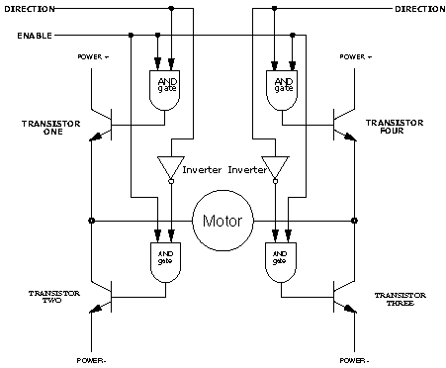

It should be clear that one would never want to enable Transistors One and Two or Transistors Three and Four simultaneously. This would cause current to flow from Power + to Power - through the transistors, and not the motors, at the maximum current-handling capacity of either the power supply or the transistors. This usually results in failure of the H-Bridge. To prevent the possibility of this failure, enable circuitry as depicted in Figure is typically used.
In this circuit, the internal inverters ensure that the vertical pairs of transistors are never enabled simultaneously. The Enable input determines whether or not the whole circuit is operational. If this input is false, then none of the transistors are enabled, and the motor is free to coast to a stop.
By turning on the Enable input and controlling the two Direction inputs, the motor can be made to turn in either direction.
Note that if both direction inputs are the same state (either true or false) and the circuit is enabled, both terminals will be brought to the same voltage (Power + or Power - , respectively). This operation will actively brake the motor, due to a property of motors known as back emf, in which a motor that is turning generates a voltage counter to its rotation. When both terminals of the motor are brought to the same electrical potential, the back emf causes resistance to the motor's rotation.

Stepper motors

Stepper motors are special kind of heavy duty motors having 2 or 4 coils. The motors will be stepping each time when it get the pulse. As there are many coils in the motors we need to energize the coils in a specific sequence for the rotation of the motor. These motors are mostly used in heavy machines. The figure shown below consists of a 4 coil stepper motor and the arrow mark will rotate when the coils are energized in the sequence.

Unlike DC motors stepper motors can be turned accurately for the given degrees.

Servo motors

Servo motors unlike the stepper motor it has to be controlled by the timing signal. This motor has only one coil. It is mostly used in robots for its lightweight and low power consumption. The servo motors can also be accurately rotated by the making the control signal of the servo motor high for a specific time period. Actually the servo motor will be having 3 wires where 2 are for power supply and another one is for the control signal. Driving the servomotors is so simple that you need to make the control signal high for the specific amount of time. The width of the pulse determines the output position of the shaft

Object Detection

﻿Detecting objects without whiskers doesn’t require anything as sophisticated as machine vision. Some robots use RADAR or SONAR (sometimes called SODAR when used in air instead of water). An even simpler system is to use infrared light to illuminate the robot’s path and determine when the light reflects off an object.The IR illuminators and detectors are readily available and inexpensive.

Infrared As Headlights
The infrared object detection system we’ll build on the Bot is like a car’s headlights in several respects. When the light from a car’s headlights reflects off obstacles, your eyes detect the obstacles and your brain processes them and makes your body guide the car accordingly. We will be using infrared LEDs for headlights. They emit infrared, and in some cases, the infrared reflects off objects and bounces back in the direction of the Bot. The eyes of the Bot are the infrared detectors. The infrared detectors send signals to the Microcontroller indicating whether or not they detect infrared reflected off an object. The brain of the Bot, the microcontroller makesdecisions and operates the motors based on this sensor input.

More about IR - Detector

The IR detectors have built-in optical filters that allow very little light except the 980 nm infrared that we want to detect onto its internal photodiode sensor. The infrared detector also has an electronic filter that only allows signals around 38.5 kHz to pass through. In other words, the detector is only looking for infrared that’s flashing on and off 38,500 times per second.

This prevents common IR interference sources such as sunlight and indoor lighting. Sunlight is DC interference (0 Hz), and indoor lighting tends to flash on and off at either 100 or 120 Hz, depending on the main power source in the region where you reside. Since 120 Hz is way outside the electronic filter’s 38.5 kHz band pass frequency, it is, for all practical purposes, completely ignored by the IR detectors.

As the receivers detects only modulated signals we need to have our IR LEDs modulated in 36 KHz to 40 KHz. We can use 555 timer to make this 40 KHz pulse. The simple circuit is given below.

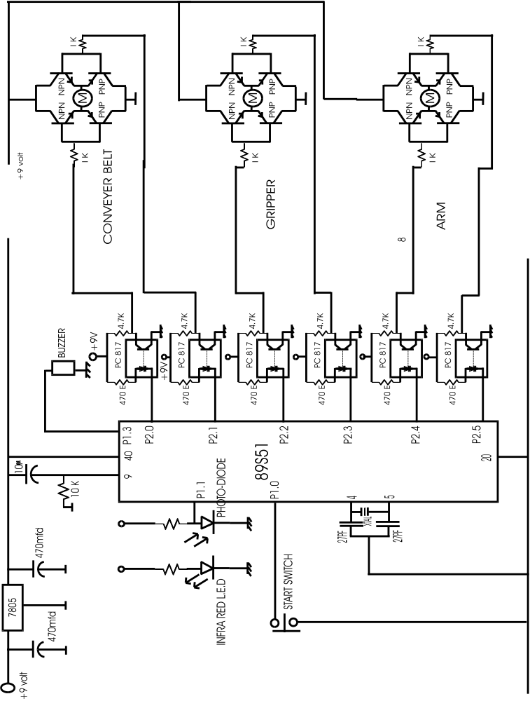

CIRCUIT WORKING:
Pin no 40 is connected to the positive supply. . 5 volt regulated power supply is provided to the pin no 40. Pin no 9 is connected to the reset pin. On this pin we connect one 10 mfd capacitor and 10 k ohm resistor. With the help of this capacitor and resistor we force the micro controller to start up from the 0000h location when start. Start switch is connected to the pin no p1.0. On this pin we use push to on switch. When we press this switch then pin no p1.0 become more negative and circuit start and conveyer belt is on move. Conveyer belt is start because p2.0 and p2.1 pins are give a pulse to the H bridge circuit to give a voltage to the dc motor. When dc motor is on then conveyer belt is on with the help of h bridge circuit.. now program is shifted to infra red sensor, if there is any obstruction against infra red led then infra red sensor sense the signal and at this time port p1.1 is more negative and circuit stop the conveyer belt. When conveyer belt is stop then second motor is switch on to grip the object. When object is gripped then third motor is on and move the object to the basket, third motor is connected to the p2.4 and p2.5. One buzzer is connected to the port p1.3, this buzzer is on when infra red sensor sense the signal . .

Control of motor is done by the H bridge circuit. In the H bridge circuit we use two npn transistor and two pnp transistor. With the help of this two npn transistor and two pnp transistor we control the direction of the motor.

H bridge is interface with the microcontroller with the hel p of opto-coupler circuit., Opto-coupler circuit not only interface the microcontroller with the H bridge but also provide a electrical isolation between microcontroller and dc motor circuit.

PROGRAM CODE OF THE MICROCONTROLLER.
org 0000h
ORG MEANS ORIGION , ON THIS POINT WE START THE PROGRAM CODE , WHEN MICROCONTROLLER IS ON THEN PROGRAM IS RESET AUTOMATICALLY AND START FROM THE 0000 LOCATION.
sjmp main

main:

jnb start,s1
sjmp main

s1:
clr p2.0 ; motor1 for conveyer belt
setb p2.1 ; motor1
jnb input,s2 ; input for the ir sensor
sjmp s1

s2:
setb p2.0 ; stop the motor
setb p2.1 ; stop the motor1( conveyer belt)

clr p1.3 ; buzzer on

acall delay1
setb p1.3 ; stop buzzer

clr p2.4 ; start motor3 forward
setb p2.5 ; start motor3 forward
acall delay2
setb p2.4
setb p2.5

setb p2.2 ; start motor 2 reverse
clr p2.3 ; start motor 2 reverse

acall delay1
setb p2.2
setb p2.3
setb p1.3 ; stop the alarm

D1: CLR p2.4
SETB p2.5
JB P1.2,D2
SJMP D1

acall delay2
D2: CLR p2.4
setb p2.5

